Samir Rodriguez

Module 1

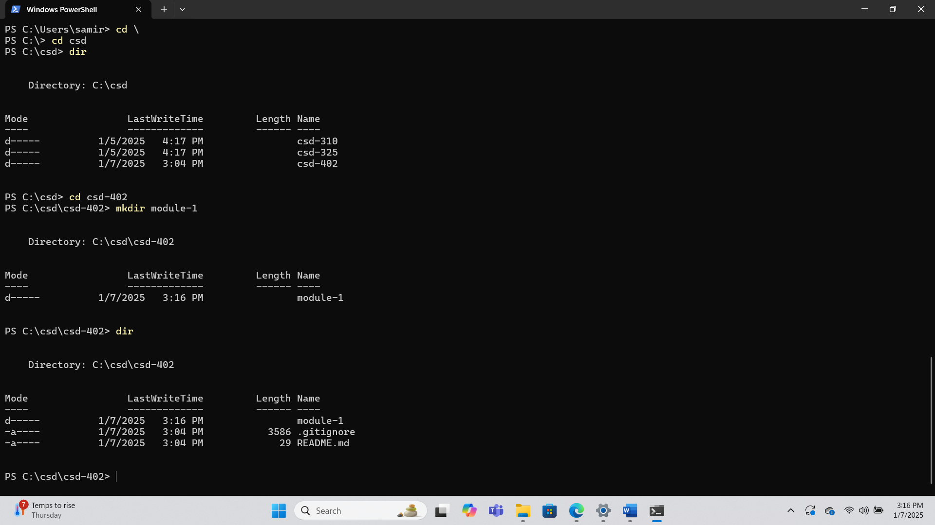[Deus-cold/csd-402: Projects of Java](https://github.com/Deus-cold/csd-402)